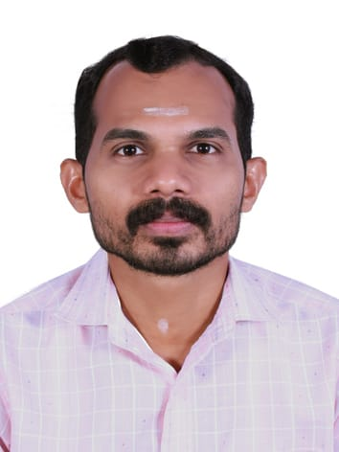
NAVEEN KUMAR P
Assistant Professor
Department of Physics • Government College, Kasaragod, Kerala
naveennaik309@gmail.com
Ph: 9686223288
EDUCATION
M.Sc. Physics | 2016 | Mangalore University
B.Sc. Physics | 2014 | Mangalore University
B.Ed. Physical Science | 2019 | Kannur University
Qualified CSIR-UGC-NET | 2017 and 2022
Qualified SET - Physics | 2020
ACADEMIC PROFILE
Assistant Professor / Faculty | August-2026 – Continuing
Govt. College Kasaragod, Kerala, India

Assistant Professor / Faculty | March -2026 – August 2026
EKNM Govt. College Elerithattu, Kasaragod, Kerala, India

HSST Physics / Faculty | June - 2022 – March - 2026
GHSS Kundamkuzhy, Kasaragod
GHSS Chavassery, Kannur
GHSS Kozhichal, Kannur
TEACHING INTERESTS
Classical Mechanics
Nuclear and Particle Physics
Methods in Mathematical Physics
Condensed Matter Physics

