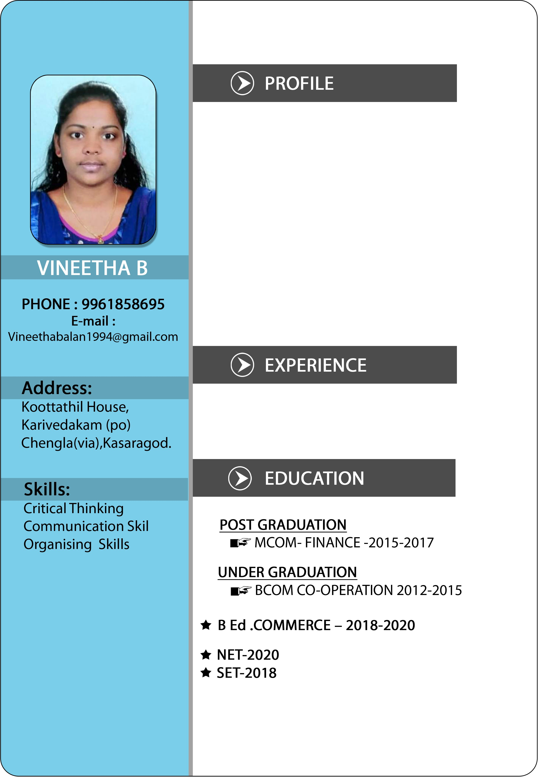

Dedicated and knowledgeable instructor with strong understanding of teaching in Commerce. Committed to enhancing overall student success by maintaining productive relationship with students and parents and updating educational protocols. Industrious educator with solid history of successfully stepping into diverse classroom environment and supporting students with solid lectures, discussions and activities.

17 Months experience as Assistant Professor in Govt Arts and Science College Uduma.

