CURRICULUM VITAE

Dr. Radhakrishna N. Bellur  ASSOCIATE PROFESSOR  Dept. of P.G. Studies and Research in Kannada  Government College  Kasaragod 671123  Kerala STATE  CELL 09495 10 4578 MAIL radhabellur@gmail.com | 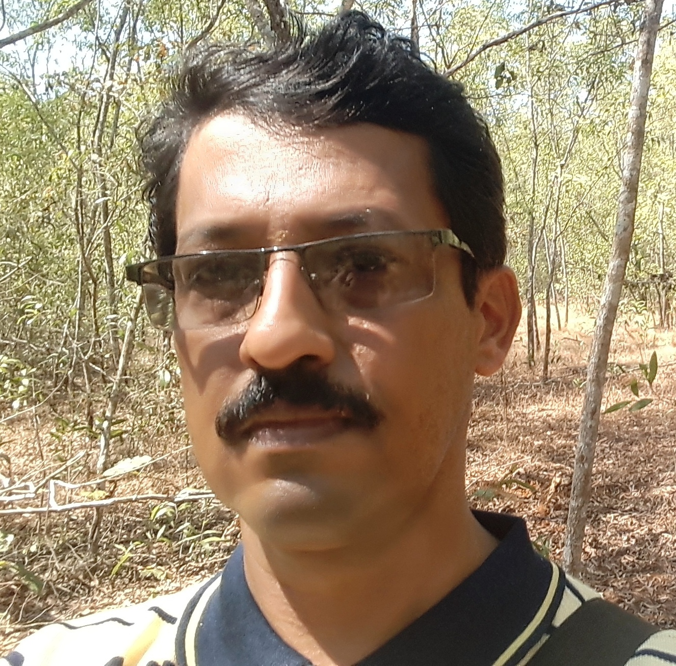

Educational qualifications
- Ph.D. in Kannada 2006, Kannur University
- M.Phil. in Kannada 2000, Kannur University
- M. A. in Kannada with First Rank 1995, Calicut University
- B.A. in Kannada with First Rank 1993, Calicut University
Research interests

- Linguistics
- Archives
- Modern Literature
- Tulu Language and Literature
- Ancient Literature

Positions Held

- Chairman, BoS Kannada, Kannur University 2024
- Convener, Ad-hoc Committee for preparing UG Syllabus, Kannur University 2024
- Member, Committee for Language and Literature, implementation of Four Year Under Graduate Programme, Kannur University 2023
- Convener, Ad-hoc Committee for preparing PG Syllabus, Kannur University 2023
- Chief Superintendant, Sri Narayana Guru Open University Examinations 2023
- Member, BOS Kannada, Vivekananda Autonomous College, Puttur 2022
- Convenor, NAAC accreditation steering committee 2022
- Member, Academic Committee, DCE, Kerala 2022
- Chief Superintendent For Examinations in Covid period for Calicut, Kerala and MG University 2020
- Chairman, BOS Kannada UG and PG, Kannur University 2018-2022
- Member, BOS Tulu PG, Mangalore University 2018-2024
- Member, BOS, Kannada UG, SDM Autonomous College, Ujire 2020-2024
- Member, BOS, Kannada UG, St. Aloysius Autonomous College, Mangalore 2019-2021
- Member, BOS Kannada PG, Central University of Kerala, 2020-2022
- Member, Consultative Committee, Central University of Kerala 2019-2020
- Member, Consultative Committee for Kannada MA, Central University 2019
- Member, BOS, Tulu Language and Literature, Mangalore University 2019 onwards
- Member BoE Kannada, Mangalore University 2019 onwards
- Director, Centralized Valuation Camp, Kannur University 2018 onwards
- Expert, DRC, Kannur University, 2018
- member, BOE and DoS Mysore University 2016 onwards
- Chief Superintendant, University Examinations 2016 onwards
- BOE Chairman UG Kannur University 2016
- College Development Council Member Government College, Kasaragod Feb. 2016 - 2019
- Coordinator, UGC Cell from 2018 to 2022
- RUSA Coordinator 2015-16 at Government College, Kasaragod
- IQAC Coordinator 14 June 2014 to 27 July 2016 at Government College, Kasaragod
- Staff Council Member –Elected -2013 and 2014 at Government College, Kasaragod
- BOE [PG] Chairman, Kannur University 2013-2015
- Founder Editor of ‘KASARA’ Humanities Research Journal with ISSN 2012-2015
- NAAC Re Accreditation Committee Coordinator 2012-13 at Government College, Kasaragod
- Staff Advisor for College Union 2011- 12 at Government College, Kasaragod
- Member, Advisory board of District Library Council, Kasaragod 2011
- PTA Secretary 2009-10 at Government College, Kasaragod
- member, board of Studies, Kannur University 2008 – 2010
- Subject Expert, Scrutiny Committee for Kannada Text Books under SCERT Kerala 2001 onwards
- Language Expert, Scrutiny Committee for Translated Text Books for Kannada medium under SCERT Kerala 2006 onwards

Curriculum Developement

- FYUGP Kannada, 2024
- SCERT Kerala 2023
- MA Kannada, Kannur University 2023
- MA Kannada, Central University of Kerala 2019
- UG Tulu, Mangalore University 2019
- Tulu Diploma, Kannur University 2019
- UG Kannada, Kannur University 2019
- SCERT Kerala 2015
- UG Kannada, Kannur University 2014
- SCERT Kerala 2014
- SCERT Kerala 2010
- SCERT Kerala 2006

Publications
A. Books

      - TULU SHASANAGU – Published by Mangalore University 2022
      - KASARAGODINA KANNADA PRAJNE – Published by Kannada Development Authority, Government of Karnataka, 2021
      - KARADA MARATHI KANNADA PADAKOSHA – Published by KBBP, Government of Karnataka, 2021
      - TULU LIPI - Research on Tulu script and Inscriptions 2019
      - Dr. P. SHRIKRISHNA BHAT –Life sketch 2018
      - NEMMADIYA DAARI –Life sketch 2018
      - GADINAADA DEEPA –Research-Life sketch 2016
      - TULU CHANDASSU –Research 2016
      - BHAGAVATHARA BHAGAVATHA – Research on Yakshgana Artist 2015
      - SHABDA SOOTHAKA -Articles 2011
      - ANANTHA VRUTHA KATHE - Edited from palm leave manuscript 2010
      - GANAKIKRUTHA TULU LIPI - Research on Tulu script 2009
      - karaAda padakoosha - dictionary of Karada Language 2008
      - TULU LIPI PARICHAYA - Research on Tulu script 2007
      - BHAASHANA KALE - On public speaking 2005
      - kasaragodina karaada upabhaashe - research 2001
      - AGNIJIHWAa - Collection of Poems 2001
      - VYAaVAHARIKA - Educational 1999
      - SWARAAJYA -Research –Collected works of P.L.N.Puninchathaya 1999
      - KASARAGODU 97 - directory on kannada Literature of Kasaragod 1998
      - P.L.N. PUNINCHAThAYA - Life and works 1998
      - MUGILA NERALINA BADUKU -Collection of Poems 1995
      - PUNDUURU - Research 1993

B. Articles In Journal

- Tulunadu Mattu Bahubhaashikate - Aruhu Kuruhu2021Vol. 12. 45 Special Issue ISSN 2347-5048
- Belagina Abhivyakthi: Eradu Bhinna Maadarigalu – Shodha, Jan 2022, UGC Care Listed, ISSN 2249-0396
- Kannadadalli Hasys Sahithya - International Journal of Kannada Research, 2021Vol. 7, Issue 4. Part C. 2021, ISSN 2454-5813
- Lipirupagala Rachanika Vinyasa - Aruhu Kuruhu, Volume 12, Special Issue, July – September, 2021, ISSN 2247 - 5048
- Vachanagala Tatvikathe – Aruhu Kuruhu, Volume 12, Issue 45, July – September, 2021, ISSN 2247 - 5048
- Literary Magazins and South Indian Poetry, International Journal of Kannada Research, Volume 8, Issue 1, July - September, 2021, ISSN 2454 - 5813
- Karavali Karnatakadalli Tulu Bhasheya Shasanagalu – Chinthana Bayalu. Volume 9, Issue 4, April- June, 2021, ISSN 2278 – 2192
- Kasaragodu Parisarada Sthalanaamagalu - Abhijatha Kannada, Vol. 7. Issue 4. 2021, ISSN 2347-4017
- Aadhunika Tulu Sahithya Mattu Abhivyakthiya Nelegalu - International Journal of Kannada Research, Volume 7, Issue 2, April – June, 2021, ISSN 2454 - 5813
- Sanskrit domination : Defending strategy of Kannada – International Journal of Kannada Research, Volume 7, Issue 1, January – March, 2021, ISSN 2454 – 5813
- T.S. Eliot na Kavya chinthanegalu - KASARA Journal of humanities, 2015, Vol. 4, Issue 1. ISSN 2320-2580
- Tulu Lipi : Parishkarada Hadi - Kannada Lipi Vagvada, Full Paper in a Proceedings
of National Seminar 2014
- Tulu Karnaparvada Kavi - Dravida Adhyayana, Kannada University, Hampi, Vol. 8, Issue 2, July 2009, ISSN 2250-1614
- Tulu Chandassu - Dravida Adhyayana, Kannada University, Hampi, Volume 5, Issue 1, Jan. 2006, ISSN 2250-1614
- Kasaragodu – Malayalamninda Kannadakke Shabdagala Eravalu – Dravida Adhyayana, Kannada University, Hampi, Volume 4, Issue 2, Jul. 2005, ISSN 2250-1614

C. Chapters in Books

- Maadhyama Vyaayoga emba maadhyama Neethisamhithe - Sogasu Kaanuva Manasu - Niranjana Vaanalli Abhinandana Samithi, SDM College, Ujire – 2016 – ISBN 978-81- 926593-0-5
- Neeru Bedi & Neera Beli - Dakshina Bharathiya Krushi Vijhnaana Kosha - Folklore University, Karnataka – 2014 – ISBN 978-93- 83149-20-9
- Yakshagana Pradarshana - Kannada Vaijayanthi - Alvas Prakashana, Moodabidiri – 2013 – ISBN 978-93-83765-06-5
- Tappuva Daarigalu – Bahumukhi - Vismaya Prakashana Mysore – 2012 – ISBN 978-81-92202-65-6
- Kruthi Chintana Emba Kruthi Chintana – Vidvajeevitha – Rastrakavi Govinda Pai research Centre, MGM College, Udupi – 2011 – ISBN 81-86668-69-1
- Haribhakthi Saara – Kanaka chinthana – 2013 – Kanakadasa Research Center, Mangalore University
- Jeeve Ulisuva kalegalu - Marudibbana – Janapada Prakashana, Honnavara – 2010
- Nenapugale Banni – Jeeva Vruksha – Banari Abhinandana Samithi, Sulya - 2010
- Tulu – Karada – Tulu Sahithya Charitre – Kannada University, Hampi – 2007
- Balya Jeevana Saadhane – Gadinada Deepa – Karnataka samithi, kasaragod – 2007
- Hindu Temples - Kasaradod : History and Society – Kasaragod District Panchayath – 2004
- Kannada Literature - Kasaradod : History and Society – Kasaragod District Panchayath - 2004
- PLN Puninchathaya – Hombidiru – 71st All India Kannada Literary Conference, Moodabidire, 2003

Workshop/Seminar presented - Invited Talks
- Invited talk in the National seminar at SDM Autonomous College, Ujire 2024
- Paper presented in a National Seminar at Bhuvanendra College, Karkala 2024
- Invited talk at Excel P U College, Guruvayanakere, 2024
- Invited talk in Kannada Refresher Course under UGC HRDC, Mysore University 2021
- Resource person in National level Online Lecture series, conducted by Central University of Kerala 2021
- Resource person in Value added course on epigraphy conducted by Department of Malayalam, Calicut University 2021
- Invited talk on TS Eliot in online mode Conducted by Karnataka Sahithya Acadamy 2021
- Resource person in a National Seminar at St. Ann’s Women’s College, Bangalore 2020
- Resource person in a National seminar organized by St. Ann’s College, Bangalore on Pampana Kavyagala Soundarya 2020
- Resource person in a State level seminar on feasibilities of online teaching in UG Kannada classes organized by Govt. First Grade college, Bettampady 2020
- Invited talk in the Refresher Course, UGC HRDC Kannur University 2020
- Resource person in a National Seminar organized by Mangalore University at Kasaragod, titled Bhakthi Parampareya Lokayana Mattu Kanakadasaru 2020
- Resource person in a National Seminar organized by Siddamangala Seva Kendra, Bangalore 2020
- Presented a Paper in a National Seminar on Contemporary Trends in Kannada Short Story organized by Department of Kannada, Kannur University 2020
- Resource person in a work shop on Tulu script at Vivekananda College, Puttur, Karnataka 2018
- Presented a paper in a National Seminar on Thulu Language and Culture organized by Department of Malayalam, Kannur University 2018
- Resource person in a National Seminar on Yakshagana at Dhavala College Moodabidiri on 19.1.2019
- Resource Person for Refresher Course, UGC ASC, Kannur University 2019
- Special Lecture on Social issues in Ambigara Choudayya’s Vachana Literature at Govt. College College, Mangalore, Organized by Mangalore University on 04.05.2019
- National level Seminar on Contemporary Kannada Literature on 21st 22ndand 23rd of March 2019 at Kasaragod under the Department of Kannada, School of Indian Languages, Kannur University
- State level seminar on Kuvempu Literature at Mysore University on 29, Dec. 2018
- National level Seminar on Multi Lingual setup in costal Karnataka on 23rd and 24th of March 2018 at Mangalore University under UGC SAP Project
- Resource person in the state level seminar at Puttur on Tulu Mahabharatho organized by Tulu Sahithya Acadamy, Government of Karnataka on 18.03. 2017.
- UGC Sponsored National Seminar on The Art of Translation and Creativity on 16 and 17 February 2017 at Dravidian University, Kuppam, AP.
- State level seminar on Kannada Literature and Mutual Translations at University College, Mangalore on 9thJanuary 2017 sponsored by Central Sahithya Acadamy.
- National level Seminar on Concept of Bhakthi in Midual Kannada Literature on 2nd and 3rd of December 2016 at GPM Government College, Manjeshwara
- National level Seminar on The Cultural Identity of south Indian Short Stories, on 2,3 and 4 of November 2016 at Brennens Government College, Thelechery.
- National level Seminar on The Niranjana Life and works, on 29th January 2016 at GPM Government College, Manjeshwara
- National level workshop on The present and future of Social sciences, on 10th March 2015 at Government First Grade College, Bantwal, Karnataka
- UGC Sponsored National Seminar on Kannada Literature in 21st century : Challenges Possibilities on 26 and 27 August 2014 at Milagres College, Kallianpur, Udupi district, Karnataka
- UGC Sponsored National Seminar on Research feasibilities in Kannada in the background of Classical Language on 26 February 2014 at Cavery first grade College, Gonikoppal, Karnataka
- National Seminar on Heritage of India in the Development of Arabic Language and Literature, on 30 and 31, October 2013 at Government College, Kasaragod
- UGC Sponsored National Seminar on Cultural and Acadamic implications of common syllabus on 30th September 2013 at Sri Dhavala College, Moodabidiri, Karnataka
- State level seminar held at SDM Autonomous College, Ujire on 23 August 2013
- National Seminar on Feminist Literature in Kannada, on 30.11.2012 at GPM College, Manjeshwara.
- National Seminar on Possibilities in the Comparative Study of Literature in the background of Multi Lingual Setup, on 29.02.2012 at GPM College, Manjeshwara.
- National Seminar on Higher Education in India –Challenges and Prospects, Organized by Kannur University from 13.12.2011 to 15.12.2011 at the University Campus.
- National Seminar on Re Reading of Manipravala Kavyas, Organized by The Department of Malayalam, Kannur University on 20 & 21th October 2011 at Nileshwara.
- Delivered Special talk on Hari Bhakthi Saara under Kanakadasa Research Center of Mangalore University at GPM College, Manjeshwara on 28 October 2011
- International level World Kannada Conference at 22.03.2011 at Belegavi Organized by Government of Karnataka
- Delivered Special talk on Ancient Tulu Literature under the Tulu Chair of Mangalore University at SSFG College, Subrahmanya on 24.01.2011
- National Seminar on Folklore and Gender issues, Organized by CIIL Mysore, in association with Department of Malayalam, Kannur University on 11 & 12th November 2010 at Nileshwaram.
- U.G.C. Sponsored State Level Seminar on ‘Research feasibilities in Karavali Calture’ held on 01. 05. 2010 at Govt. First Grade College, Tenkanidiyoor, Udupi.
- National Seminar cum Workshop on Malayalam- Kannada Bilingual Bidirectional Computer based Dictionary Project, from 22.03.2010 to 26.03.2010 conducted by CIIL Mysore. A project of Central Govt. at Kannur University Campus Nileshwaram
- Hon. Dasara Poets Meet at Mysore held on 25Sept. 2009
- National Seminar cum Workshop on Malayalam- Kannada Bilingual Bidirectional Computer based Dictionary Project, from 30.09.2009 to 04.10.2009 conducted by CIIL Mysore. A project of Central Govt. at Karnataka University, Dharawad.
- National Seminar on ‘Multi Level Discourse on Kannada Literature’held on 10. 11. 2008 at G. P. M. Govt. College, Manjeshwara.
- National Level 74th kannada Literary Conference held at Udupi from 12 to 15 Dec. 2007
- Two day workshop on Study of Tulu Script and Manuscript Preservation organized by Karnataka State Archives Dept., KarnatakaTulu sahitya Academy, Govt. of Karnataka and Dept. of Kannada, Kannur University, held on 04 and 05 august 2007 at Kasaragod.
- Three day workshop on Tulu Script and Manuscripts organized by National Mission for Manuscripts, New Delhi, and Karnataka State Archives Dept., Bangalore, held on 17, 18 and 19 May 2007 at Udupi.
- National Seminar on Tulu and other Dravidian Languages held on 27 and 28 Feb. 2007 at Dravidian University, Kuppam, A.P.
- National Level 72th kannada Literary Conference held at Bidar on 27, 28 and 29 Jan. 2006

Training undergone
- Short term course on Human Rights and RTI Act from 10.02.2019 to 19.02.2019 at UGC HRDC, Kannur University from 12-11-2015 to 13-11-2015.
- Short term course on Gender Studies from 12.12.2018 to 18.12.2018 at UGC HRDC, Kannur University
- Refresher Programme in Comparative literature from 2.12.2015 to 22.12.2015 at UGC HRDC, Kannur University
- Refresher Programme in Comparative literature from 5.10.2010 to 26.10.2010 at UGC ASC, Kannur University
- Orientation Programme from 3.1.2008 to 30.1.2008 at UGC ASC, Mysore University
Seminar/workshop organised

- Two day workshop on New Dimensions to Career Advancement in Higher Education for PG Students at Govt. College, Kasaragod on 13 and 14 March 2012
- Pracheena Kaavya Saahitya Gosthi –a Seminar on ancient Kannada literature under Kannada Development Authority of Karnataka Govt. on 01.04.2013 at Govt. College, Kasaragod.
- Two Day National Seminar On The Literature of Kayyara Kinhanna Rai, sponsored by Ministry of Kannada Culture, Govt. of Karnataka held on 22 and 23 July 2016
Extension Activities

- Resource Person, UGC Academic Staff College, Mysore University 2021 onwards
- Resource Person, UGC Academic Staff College, Kannur University 2004 onwards
- Expert in Various KPSC interview Boards
- Expert in the Kannur University Interview Board
- Chief Superintendent of Kannur University Examinations 2006 onwards
- Master Trainer for training the enumerators for Census 2011
- External Chief Superintendant, Kannur University Examinations, GPM Govet. College, Manjeshwar
Ph.D. Guided:
A. Awarded
- Dravidian Modern Poetry, 2018, Balakrishna B M, Kannur University
- Dravidian concept in Thiya’s worships, Shreedhara N, 2019, Kannur University
- Palamtulu kavyagalu-Samskrithika Mukhamukhi, Sandhyakumari P, 2019, Kannur University
- Kannada mattu Malayala bhashegala mahila sanna kategalalli sthree prajne Savitha B., 2019, Kannur University
- Jaagateekaranada sandarbhadalli Kannad sanna kateglu, 2019, Soumya P, Kannur University
- Animal metaphors in Kannada literature : An alternative interpretation – Ravishankara G K, Kannur University
B. On Going

4 Scholars under School of Indian Languages, Kannur University

Research Projects

- Morphological Analysis of Karada Dialect : MRP Under UGC 2012-2013

Languages Known
- Kannada Write, Read and Speak
- Malayalam Write, Read and Speak
- Tulu Speak
- English Write, Read and Speak
- Karada Speak
- Marathi Naika Understand
- Konkani Understand
- Sanskrit Understand
- Hindi Understand
- Urdu Understand

Additional information’s

- Traced, Edited and Published 42 Inscriptions in Tulu Language and Script
- Done Manuscript Survey Under Karnataka Archives Department, Bangalore in 2010
- Founder Editor of Humanities Research journal KASARA Published by IQAC of Government College, Kasaragod with ISSN No. 2320-2580
- Broadcasted more than 100 Talks from AIR

